E-commerce Web operation description document

The project is written in Java using IDEA and the runtime environment is Tomcat 9

1. Modify the database connection

Modify the database connection in the DBConnect file under the db package

Change the local database storage address on line 10

Change the database account user name on line 11

Change the password of the database account on line 12

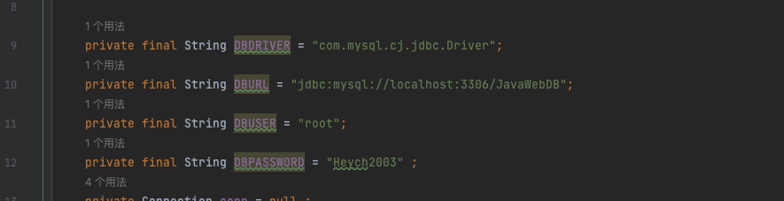

2. Modify the website read data document

Modify the web site display data document in the GetDataServlet file under the servlet package

Modify the robot "Running Time" document at line 24 (Telecom majors)

Modify the robot "Treasure Statistics" document at line 25 (IoT majors)



3. Change the URL of the robot camera

In the WEB package, the datalist.jsp file in the WEB-INF package is displayed

on line 60. Change the camera URL connection address